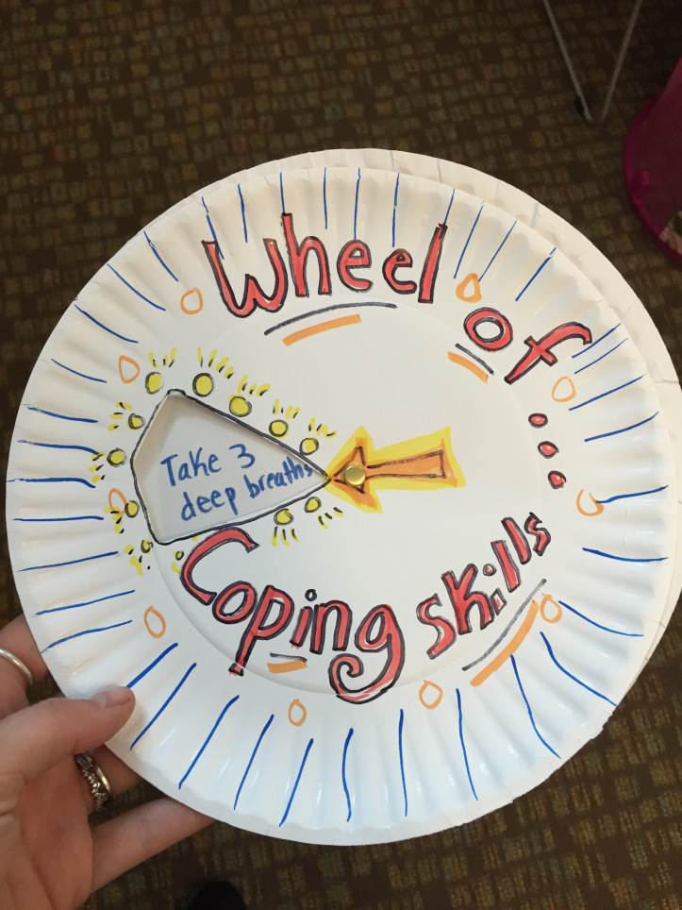
Wheel of coping skills!!
1) Take two paper plates and cut out a small triangle towards the middle of one plate.
2) spin the plate and write the skills in each section of the second plate that is exposed in the section that was cut out.
3) insert a paper fastener so the plate can spin and reveal the skills.
4) decorate any way you like!

